Design Phase of the Joint Project around the Senegal Mauritanian Aquifer Basin led by the Regional Working Group

Deliverable number 5:

Report on capacity assessment

DOCUMENT STATUS: APPROVED BY THE REGIONAL WORKING GROUP

  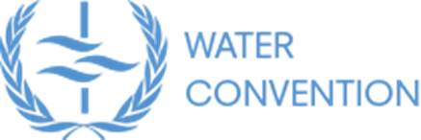 | 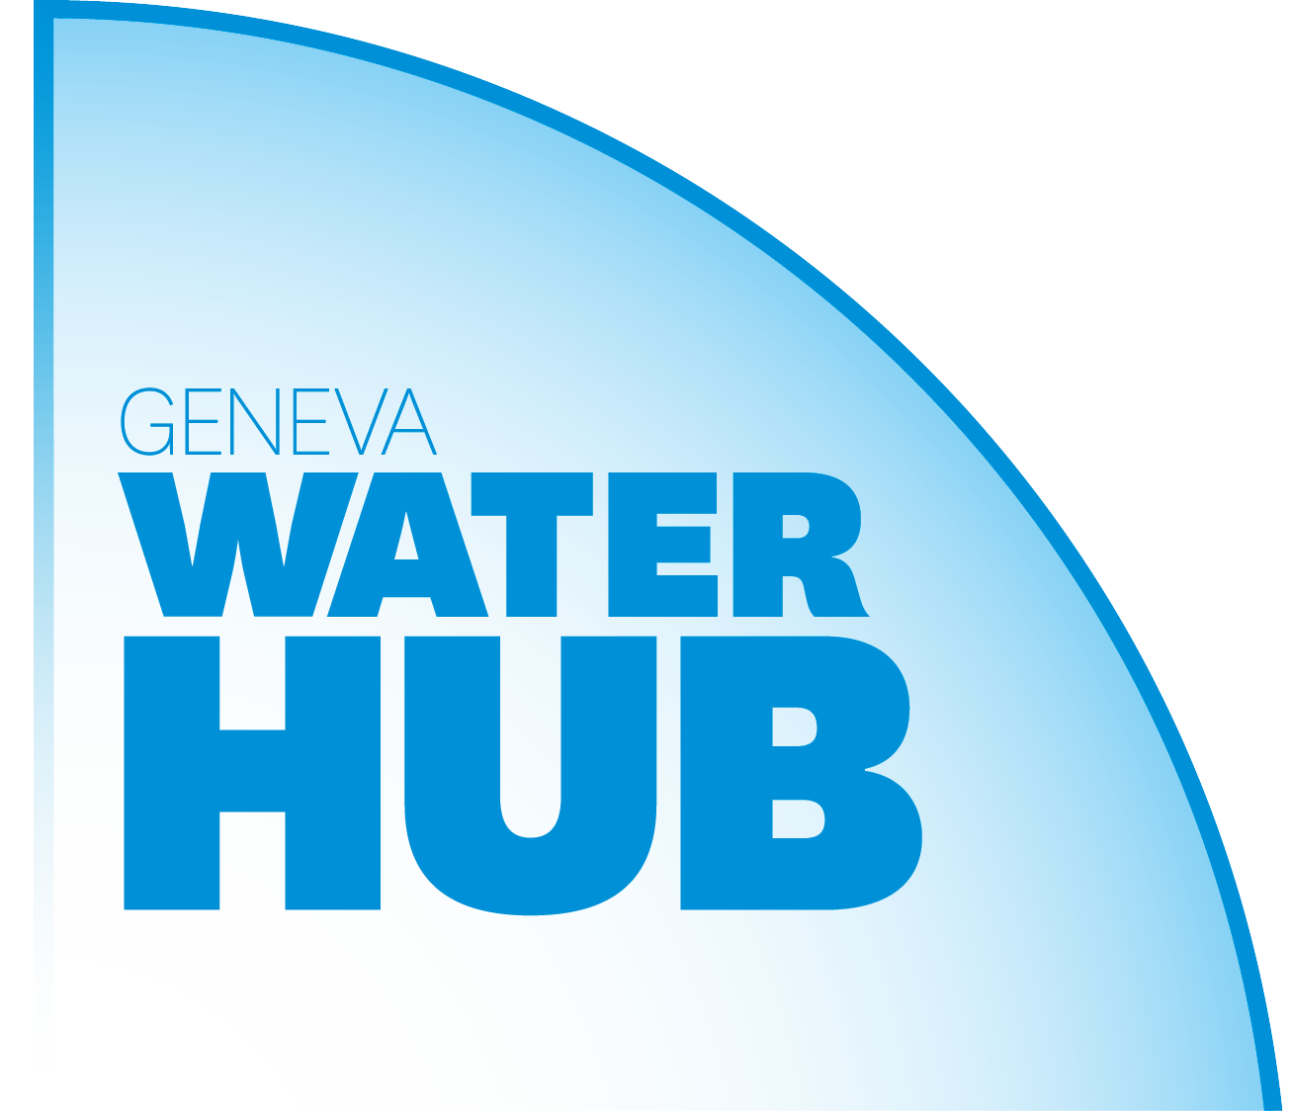 | 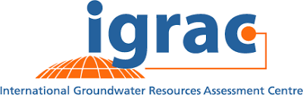
With the financial support of
 |  | 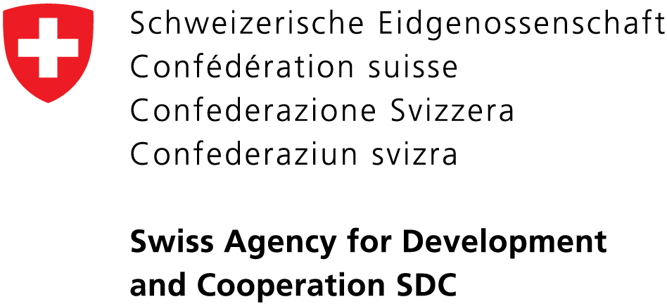

Table of Contents
1 Introduction 4
2 Inventory of State of groundwater management 4
2.1 Gambia 4
2.1.1 General overview of groundwater use and institutional setting 4
2.1.2 Collection and management of borehole data 5
2.1.3 Groundwater monitoring 6
2.2 Guinea-Bissau 7
2.2.1 General overview of groundwater use and institutional setting 7
2.2.2 Collection and management of borehole data 7
2.2.3 Groundwater monitoring 8
2.3 Mauritania 8
2.3.1 General overview of groundwater use and institutional setting 8
2.3.2 Collection and management of borehole data 9
2.3.3 Groundwater monitoring 9
2.4 Senegal 10
2.4.1 General overview of groundwater use and institutional setting 10
2.4.2 Collection and management of borehole data 11
2.4.3 Groundwater monitoring 11
2.5 OMVS and OMVG 12
3 Management issues and recommendations 12
i. Groundwater governance 12
ii. Borehole licensing 13
iii. Groundwater monitoring 13
iv. Research and knowledge gaps 14
v. Data storage 14
vi. Data sharing 14
vii. Engagement of drinking water supply companies 14
viii. Translating data into information 15
ix. Awareness-raising in communities 15
x. Improvement of drinking water supply 15
xi. Education in hydrogeology 15
xii. Professional training 15
xiii. Sustainable financing 16
4 Conclusion 18

Introduction
This report provides an overview of the state of groundwater management in the four riparian states, with a focus on the collection and the management of groundwater data. Much of the information presented here was collected during consultations with professionals engaged in groundwater management, development or protection in the countries. In total, 29 professionals were engaged, as summarized in Table 1. Intermediary reports of the consultations were made for each country, which are given in annex. The outlines of groundwater management in each country are given in section 2. In section 3, a summary of management issues is presented, with recommendations for capacity-building activities at the regional scale, to be further discussed by the Regional Working Group.

Table 1 Numbers of professionals consulted.
Organisation type | Gambia | Guinea-Bissau | Mauritania | Senegal | Total
Water department | 2 | 5 | 2 | 2 | 11
Other governmental* | 1 | 1 | - | - | 2
Water utility company | - | 1 | - | 2 | 3
University | - | - | - | 1 | 1
Consultants, drillers | 1 | - | 1 | 2 | 4
NGOs, international agencies and donors | 3 | 2 | - | - | 5
OMVS/OMVG | - | - | - | 3 | 3
Total | 7 | 9 | 3 | 10 | 29
*Other governmental:
- Gambia: Public Utilities Regulatory Authority (PURA)
- Guinea-Bissau: SERVIAGUAS – Public company for Hydrogeological Studies and supervision of borehole construction

State of groundwater management

Gambia

General overview of groundwater use and institutional setting
Groundwater is the only source of drinking water in the Gambia. All households, the tourism sector and industries rely on groundwater, through boreholes or cheaper hand-dug wells. The use of groundwater in the agriculture is also significant. It is rising with the growth of cash-crop agriculture and horticulture, in particular in peri-urban areas.
The Department of Water Resources (DWR) in the Ministry of Fisheries and Water Resources is the main institution in charge of groundwater in the Gambia. Under the IWRC Act. 1979, the DWR is responsible for groundwater abstraction licensing. Through the Divisions of Hydrology and Water Quality (Figure 1), it coordinates the monitoring of groundwater levels and groundwater quality in the country. Next to DWR, there are 3 important institutions:
- The National Water and Electricity Company (NAWEC) is mandated to provide water supply in the Greater Banjul Area and in the surrounding provinces. Not all inhabitants are connected to the public water supply network though, and many households rely on private boreholes or hand-dug wells.
- The National Environment Agency (NEA) is responsible for solid waste management, establishment of water quality standards, environmental pollution control (including those that could lead to water pollution) etc.
- The Public Utilities Regulatory Authority (PURA) offers monitoring services in the sectors of energy (oil), telecom and water. It monitors groundwater quality (in cooperation with the Water Quality Division at DWR) and the infrastructure of NAWEC, as well as wastewater. It also controls the quality of water upon request. Everybody can introduce a request.
In 2011-2015, the African Development Bank (AfDB) supported a project to reform the water sector, a.o. to promote the integrated water resources management (IWRM) and thus proposed a draft bill to establish the National Water Resources Management Authority. The National Water Sector Reform Project also produced a new version of the Gambia Water Act. However, the reform prepared by the project hasn’t been implemented yet. Interviewees said political, administrative and technical support is being sought among key stakeholders to ensure its implementation. However, it is not clear when these recommendations will come into applications.

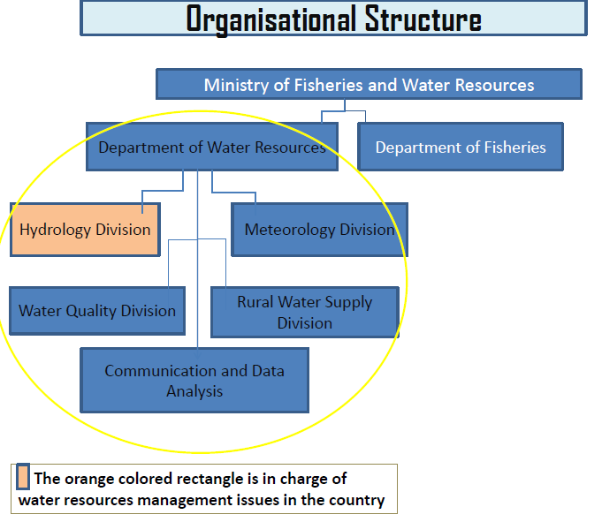
Figure 1 Organisational structure of the Department of Water Resources in the Gambia.

Collection and management of borehole data
Permits are needed to prospect, drill or abstract water above 10 m³/day. In theory, NEA is responsible for permits, at least until the new National Water Resources Management Authority is created.

Currently, there are no such permits being issued by NEA. This is the sole responsibility of the DWR under the NWRC Act 1979. Section 10 (g) of the Act. instructs the National Water Resources Committee to establish licensing system for all users and uses of water. Furthermore, Section 13 (d) states empowers DWR to initiate a system of water rights administration and regulate the development and use of water resources .
The application for permits is not enforced and borehole data are not being collected. There is currently nor comprehensive mechanism for data sharing between NAWEC and DWR. Only international organisations do sometimes ask for licenses, because they are used to do so in other countries. As a consequence, there is no monitoring and control of groundwater abstraction in the Gambia. An inventory of groundwater points was made in 2014 by Niras (Danish consultant), as part of the National Water Sector Reform Project. About 1000 groundwater points were collected, from different sources. However, there is no budget to keep this inventory going and there hasn’t been any updated. The data of the inventory were stored in a relational database called GeODin. However, some interviewee said there was insufficient training on GeODin and the main person in charge of the software has been given another assignment at some point, thus leaving the database unattended. Moreover, the software license has technically expired and thus there is no anticipated support from the supplier. Therefore, the data has been retrieved and transferred into Excel to avoid any unforeseen data lost. An ongoing project supporting the WASH sector aims at updating the inventory with a survey of wells and boreholes throughout the country. Groundwater is pumped either from the phreatic aquifer or the semi-confined aquifer, both of which constitute the Shallow Sandstone Aquifer (SSA). As the SSA covers the entire country, finding groundwater is not challenging (one interviewee said that any borehole provides at least 25 L/s) and there is little use of geophysics for siting wells, except in the western coastal area where salinity is high. Drilling reports are prepared for the borehole drillings supervised by the department staff. Drilling is not so expensive (less than 2000 USD), and can be afforded by small businesses and upper-middle class households. There is no regulation to enforce water sampling and analysis and so only borehole drilled officially send samples for analysis. A lot more do not and especially the household boreholes. Iron and manganese are important contaminants in the semi-confined aquifer, in the south-west section of the country. In case of contamination, the borehole is sealed, and the phreatic aquifer is tapped instead. On the other hand, the phreatic aquifer is more vulnerable to anthropogenic contamination, i.e. nitrates and pathogens, and to water level fluctuations. Currently, nitrate in the water supply sources is observed to be on the increase and NAWEC doesn’t have equipment to remove it from groundwater; therefore production boreholes with high nitrate content are usually decommissioned.

Groundwater monitoring

A groundwater monitoring network was launched in 2014 as part of the National Water Sector Reform Project. There is several on-going projects aim at improving it. For the moment, it consists in 38 observation boreholes distributed across the country. Wherein eighteen (18) of them are located in the Great Banjul Area (GBA) with the highest concentration of abstraction boreholes. Fifty (50) additional observation boreholes will be drilled and equipped with data loggers in the next years. Initially, all 38 observation boreholes were equipped with automatic data loggers, but many failed. Hence extra few data loggers with much higher performance rate were purchased. Since the new data loggers are more expensive, not all the boreholes could be equipped (max. 6 are currently working). The maintenance of automatic data loggers appears to be challenging. The other boreholes are measured manually at an undetermined frequency due to inadequate mobility and delay disbursement of funds... DWR currently stores the data in Excel files, which is later transferred into the Global Groundwater Monitoring Network (GGMN). The data is shared for free upon request, and DWR receives numerous requests from students, researchers, local and international consultants, projects, government agencies etc. There is no dedicated monitoring in the vicinity of production boreholes of NAWEC and other big groundwater users, or close to potential polluters (no protection or compliance monitoring). The monitoring is for detecting the general trends of national groundwater resources.

Guinea-Bissau

General overview of groundwater use and institutional setting
Groundwater is mostly used for drinking water supply. Households that are not connected to a public water supply network rely on communal boreholes (equipped with hand or electric pumps) or improved dug wells. Groundwater is also used for horticulture during the dry season.
The General Directorate of Water Resources (Direção Geral de Recursos Hídricos, DGRH) is responsible for water resources management, including groundwater. DGRH is represented at the local level by regional offices (Delegacias Regionais de Recursos Naturais, DRRH). These regional offices have no administrative or financial autonomy, they are piloted by DGRH. Only 2 or 3 DRRH are said to be operational. DGRH suffers from an overall lack of budget, staff and equipment. The National Laboratory of Public Health (Laboratório Nacional de Saúde Pública), within the Ministry of Public Health (Ministério de Saúde Pública, MSP), is responsible for the control of water quality and the issuance of water quality certificates for boreholes. After the implementation of the Water Policy in 1992, three governmental structures were created: the National Council of Water (Concelho Nacional das Águas, CNA), supported by the Inter-ministerial Committee of Water (Comité Interministerial das Águas, CIMA), itself supported by the Technical Committee of Water (Comité Técnico das Aguas, CTA). However, none of these institutions appears to be active. In general, the water sector in Guinea-Bissau is impaired by political instability, with a civil war in 1998 and consecutive putsches in 2004, 2008 and 2012.
The public water and electricity company (Electricidade e Aguas da Guine-Bissau, EAGB) is in charge of public water supply but in practice it operates only in the city of Bissau, where it manages 16 production boreholes tapping the Maastrichtian aquifer. The other cities are operated by other companies or associations (e.g. ASPAAB in Bafata, ACDB in Bambadinca, WEDE BONTCHE in Mansoa, ENAFUR in Gabu). The management of public water supply boreholes is poor. In Bissau for instance, boreholes are in the middle of the city, without protection zones and sometimes without a fence.
There is also a public company in charge of hydraulic works (SERVIAGUAS), including hydrogeological studies, specifications and supervision of borehole construction.

Collection and management of borehole data
In principle, borehole drilling projects need to be submitted to DGRH in order to be authorized and licensed. However, it doesn’t happen systematically and DGRH has no means to enforce the law. In consequence, the inventory of wells is fragmented. An inventory of 2225 boreholes collected in 2009 is stored in an Access database at DGRH. The data were made accessible in an ArcGIS database but the licenses to run ArcGIS have expired several years ago. DGRH used a software called ACTIF to store and interpret borehole data (drilling and testing), but this software is not compatible with Windows and therefore it is not in use anymore. Drillers, consultants, NGOs or water supply companies might have borehole data in their archives, with some stratigraphy, geophysical or pumping test data. In principle, a water sample is taken and sent to the National Laboratory of Public Health when a new borehole is drilled.
Recently, DGRH has received the support of UNICEF to make a survey of water points in the country, including groundwater points (boreholes, hand pumps and improved dug wells). As part of the activities with UNICEF, the following datasets have been compiled:
- Borehole data: 855 borehole data have been collected from drilling reports of boreholes supervised by DGRH. The dataset contains geographic coordinates, DGRH code, borehole/design data, drilling data, pumping test data, physical-chemical data, borehole log picture, etc.
- Groundwater quality: 744 water points were sampled for groundwater quality measurements, including pH, temperature, turbidity, electrical conductivity, iron, nitrates, E. coli, total coliforms.
- Water points: This is an inventory of 717 groundwater points, including geographic coordinates, typology of water point, type of hand pump/brand, functionality/status, mechanical problems, water depth, total depth, state of conservation of the water point (fence, apron, drainage from apron, wall, superstructure, photo, etc.).
Groundwater quality and water point data were collected with the mWater app and are therefore available in the mWater Portal. The data collection was made by trained local associations, under the supervision of DGRH and UNICEF.

Groundwater monitoring
A piezometric network was developed, amounting to 90 - 100 observation boreholes, most of which were drilled and installed in the nineties. 44 of these boreholes were in the region of Bissau. However, the network was abandoned after the civil war in 1998. Many boreholes have been turned into production boreholes, while some have been damaged or are not accessible anymore because of the vegetation. In their Annual Work Plan, DGRH and UNICEF had planned to assess the state of the observation boreholes in Bissau in 2020, but this activity has not been carried out yet. It is not clear if DGRH has any water level meter left.
Some water supply companies might have groundwater monitoring data (including abstraction rates) measured in the production boreholes under their control.

Mauritania

General overview of groundwater use and institutional setting
Groundwater is the main source of drinking water supply in Mauritania, excepted in Nouakchott, where water from the Senegal river is delivered to meet the high demand, and Rosso, located on the bank of the Senegal river. Groundwater supports also livestock during the dry season and various industries (e.g. mining industry, bottled water).
The National Centre of Water Resources (Centre National des Ressources en Eau, CNRE), under the authority of the Ministry of Water and Sanitation, is responsible for the implementation of the National Water Policy. Although it is responsible for both surface water and groundwater management, it deals exclusively with groundwater. It is a national agency, but it works closely with regional offices of water and sanitation (Directions Régionales de l’Hydraulique et de l’Assainissement, DRHA), like in the Trarza and Brakna regions (in the SMAB), where the main aquifers are located. The CNRE and the regional DRHA are said to lack capacity to fulfil their mission.
Next to CNRE, the following institutions also play a role in groundwater management:
- The National Water Supply Company (Societe Nationale de Distribution d’Eau, SNDE) manages several wellfields in the country and maintains local monitoring networks to control the performance and the protection of these wellfields.
- The National Office for Rural Water Supply (Office National de Service de l’Eau en Milieu Rural) is in charge of rural water supply (exploration, drilling and maintenance of wells).
- The National Company of Boreholes and Wells (Société Nationale des Forages et Puits, SNFP) is a company operating under the umbrella of the Ministry of Water and Sanitation.
Many NGOs operate in Mauritania to improve the access to safe drinking water, like TENMIYA, which supported the drilling of boreholes and contributed to the development of the monitoring network.
Groundwater management is ruled by the National Water Policy (Code de l’Eau) from 2005. The Policy is being revised. It is also not entirely enforced. In general, licenses are applied for when new boreholes are drilled, but fees are not paid. Only the mining industries comply with the law and pay the fees. There is an IWRM plan, but it has been applied only locally (e.g. Trarza, Brakna) and temporarily, as part of a UNDP project (when the project stopped, IWRM stopped). There isn’t any plan to implement the SDGs, although the CNRE will be given a leading role with the support of the WB.

Collection and management of borehole data
All boreholes need to be licensed and registered in Mauritania. This doesn’t apply to hand-dug wells. However, not all private boreholes comply with the legislation. The amount of data collected and reported during the siting, drilling and testing of boreholes is variable. In general, public boreholes come with a larger amount of data than private boreholes. Borehole data are recorded in a centralized database at CNRE. The database is in Access 2003 and is stored in a server, so that it can be used by the local offices across the country. The database has more than 14,000 water points, although there are data gaps (i.e. missing or incomplete records). There is no backup of the data. The data are available for free upon request.

Groundwater monitoring
Since 2000, groundwater monitoring is carried out by SNDE in the 14 wellfields it manages in the country, where measurements are taken every 3 or 4 months (according to the plan). The actual frequency of monitoring is highly variable, because it depends largely on external support from projects.
It is said that long time series are available at the wellfield of Idi, which supplied the city of Nouakchott. The wellfields in Boulenoir and Benichab units are also relatively well monitored. IAEA is currently supporting the monitoring; hence data can be collected twice per year. The wellfield in the Bennichab unit is equipped with automated data loggers supporting telemetry, but the telemetry is currently out of service. No information could be collected on the management of monitoring data (e.g. database, data sharing, interpretation). CNRE is also supposed to do groundwater monitoring in the country but it has insufficient staff and budget. In addition, the National Park of Diawling (part of the Ministry of Environment), near the mouth of the Senegal river, operates a monitoring network of 16 observation boreholes since 2015. However, the data are not shared.
There is little monitoring of groundwater quality at the well-fields. The SNDE has a lab to analyse the samples. CNRE is supposed to centralize the data but this is not happening.
The production boreholes of SNDE are equipped with flowmeters. Abstraction data are recorded in Excel spreadsheets.

Senegal

General overview of groundwater use and institutional setting
The sectorial distribution of groundwater use in Senegal is represented in Figure 2. Drinking water supply is the main use.

Figure 2 Distribution of groundwater withdrawals per sector in Senegal (in percentage of total groundwater withdrawals).

Water management falls under the responsibility of the Ministry of Water and Sanitation. Within the ministry, the Directorate of Water Resources Management and Planning (Direction de Gestion et de Planification des Ressources en Eau, DGPRE) is responsible for water management, including groundwater management. Since 2018, the national Office of Lakes and Rivers (Office des Lacs et Cours d’eau, OLAC) is responsible for the management of surface water in Senegal, except the rivers covered by an international agreement (e.g. Senegal river). The predecessor of OLAC was OLAG (Office du Lac de Guiers), which was responsible for the Guiers Lake that supplies Dakar. DGPRE manages groundwater and surface water while OCLA plans and develops inland rivers and lakes with an emphasis on development.
Other stakeholders in the water sector are:
- The National Water Company SONES (Société Nationale des Eaux du Senegal) is in charge of urban water supply infrastructure, including monitoring networks around the wellfields.
- The urban water supply network is operated by a private company. In 2020, SEN’EAU (SUEZ group) was replaced La Senegalaise des Eaux.
- The Office for Rural Boreholes (Office des Forages Ruraux, OFOR) is in charge of rural water supply infrastructure, including boreholes, wells and pipes but also drilling and construction material.
- The Waterworks Division (Direction de l’Hydraulique, DH) supervises all water works carried out in the country. It has regional offices.
- The High Council of Water (Conseil Supérieur de l’Eau, CSE) falls under the responsibility of the Prime Minister. It is an overarching institution defining the national water management strategies. It is supported by the Technical Committee of Water (Comité Technique de l’Eau, CTE).

Collection and management of borehole data
Drilling for public water supply is under the responsibility of SONES in urban areas and OFOR in rural areas. Private boreholes need to be authorized (above 5 m³/h) or simply registered (below 5 m³/h). Private borehole owners need to pay a fee. Drilling reports need to be submitted to DGPRE, including all data related to the siting, drilling, construction and testing of the borehole. These reports are normally submitted by the engineering company in charge of the works. They sometimes include water quality analyses (a sample is taken when a borehole is drilled). These boreholes are then recorded in a database. The database at DGPRE is called PROGRES and it contains over 8,000 records. As said above, the database is incomplete (records are missing or incomplete). The original reports are stored in hard copy. Since 2019, DGPRE also manages a database with data on licenses, extraction rates and fees. Apparently, DGPRE has the support of the national IT Agency, (Agence de l’Informatique de l’Etat, ADIE) to manage these server-based databases. Data from the database are shared on request. However, it was reported that these requests are not always answered in due time. At the regional level the DGPRE has decentralized structures called the Water Resources Brigade-BRE.
There is a division within the DGPRE in charge of law enforcement (e.g. issuance of permits, collection of borehole data). That division doesn’t have regional units. Permits are given by the department authorities, after inspection by the DH regional offices. The DGPRE division carries out inventories of boreholes and wells. However, it hasn’t enough staff and budget to fully enforce the law. Several interviewees have reported that few boreholes are compliant. Currently, this division targets large groundwater users (e.g. industries, mines) and tries to raise awareness among the communities to comply with the law. Boreholes drilled by SONES or OFOR (or other governmental project like at the Ministry of Agriculture) don’t need the authorization from the DGPRE but the DGPRE is often involved, so it keeps record of these boreholes. OFOR and SONES have their own databases. For example, SONES has data for about 270 boreholes, dating back to 1959. There is no common database or information management system but, in principle, these organisations share data with DGPRE.

Groundwater monitoring
Groundwater monitoring activities are carried out by DGPRE and SONES. DGPRE maintains a national monitoring network with time series dating back to the sixties. The frequency of monitoring depends on the pressure on the aquifers (frequency is higher in hotspots). It is twice per year in zone Nord, Casamance, Bassin Arachidier, Tamba et Kaffrine. In the Horst de Diass, where the pressure is higher, the frequency is rather trimestrial. Near Dakar, measures are taken monthly. However, the frequency of monitoring is also much dependent on the available budget, and therefore on projects. In 2019, DGPRE had monitored 498 points, including 290 observation boreholes, 127 boreholes, 16 boreholes/wells and 65 wells. Some boreholes are equipped with automatic data loggers. Groundwater quality parameters are monitored as often as groundwater levels. Therefore, it also depends on projects. The main challenges reported are the access to some observation boreholes, the maintenance of boreholes and automatic data loggers, as well as vandalism. There is insufficient budget and capacity. The density and the geographic coverage of the network is not enough everywhere. All data are stored in a dedicated database called CHRONO.
SONES has observation boreholes installed in the vicinity of well-fields. Those are monitored twice per year. Groundwater quality is monitored more frequently. The monitoring data from SONES are stored in Excel spreadsheets. They are not meant to be shared outside governmental institutions.
SONES and OFOR monitor abstraction at the production boreholes. DGPRE collects abstraction data from private boreholes but only a few of them are equipped with flowmeters.

OMVS and OMVG
OMVS and OMVG have been created to manage transboundary river basins. The conventions of the two RBOs (which are very similar) don’t mention groundwater. Both RBOs are willing to integrate groundwater, in a logic of IWRM, but they lack the capacity (limited number of hydrogeologists among the staff, limited equipment) and a mandate from the member states to get access to the data collected by the national departments (e.g. borehole data, groundwater monitoring data) and to engage in groundwater management.
In 2018, OMVS has started collecting groundwater data from the organisations in charge, following the recommendation of the Permanent Water Commission (Commission Permanente des Eaux, CPE). The objective is to assess where groundwater and surface water interact or can be managed conjunctively. The collection of data is reported to be challenging.
OMVG doesn’t monitor groundwater itself but supports the riparian states in their groundwater monitoring activities, with the purchase of equipment and dedicated training. Five observation boreholes have been installed as part of a project with the African Water Facility (AWF) and 5 others for an energy project. There is a protocol for data exchange among the riparian states.

Management issues and recommendations
Management issues reported by the interviewees have been listed in Table 2. It appears that most management issues are shared between the countries, which offers opportunities for transboundary cooperation. Several capacity-building activities could be implemented at the basin scale. It is possible to distinguish two categories of issues. On one hand, there are issues pertaining to the availability and the quality of groundwater resources. For example, there are cases of over-abstraction or risks of over-abstraction in several places. In coastal regions (where the population density is the highest), this can lead to seawater intrusion, as reported in the Gambia, Guinea-Bissau and Senegal. There are also several cases of contamination, either anthropogenic or natural. On the other hand, there are organisational issues, including a lack of capacity in the organisations engaged in (ground)water management. These organisational issues hinder the first category of issues to be efficiently tackled. Major organisational issues are described below, and recommendations are made to address them.

Groundwater governance
Every country has a dedicated institution in charge of groundwater management, under the responsibility of the ministry of water. However, it is often unclear what their exact responsibilities are because of ongoing institutional reforms that are not fully implemented. In Gambia, a National Water Sector Reform Project was completed in 2015, foreseeing the creation of a National Water Resources Management Authority that would centralize the management of water, taking over responsibilities from DWR (e.g. groundwater monitoring) and other institutions (e.g. borehole licensing from ENA). However, that reform has not been implemented. In Guinea-Bissau, many reforms have been launched that have never come into application, because of the political instability. Several institutions have been created that have never really been capacitated. As a result, the water sector encompasses a large number of stakeholders with unclear responsibilities. In Mauritania, the national water policy (Code de l’Eau, 2005) is being revised. In Senegal, a national Office for Lakes and Rivers (OLAC) has been created in 2018, from which it seems that DGPRE is no longer in charge of surface water (which could have a consequence on the budget and expenses of DGPRE), although the situation remains unclear. The absence of clarity in the governance framework doesn’t favour medium and long-term planning and investments. It is necessary that the responsibilities be clearly defined in order to know who to support and for what purpose.
Recommendation: It is probably beyond the scope of a transboundary project to influence the political reforms, but it should be possible to inquire of the cabinets of the ministers where the current reforms are heading to and get clarity on the responsibilities of each organisation.

Borehole licensing
In every country, boreholes need to be authorized or reported to the competent authority, where they can be recorded in a database. The licensing of boreholes serves to control the abstraction of groundwater. The fees collected from the licenses can support other groundwater management activities, like groundwater monitoring. An inventory of boreholes also provides key information for drilling new boreholes: What are the hydrogeological units in that region? At what depth is found groundwater? What are the yields of the boreholes nearby? etc. However, the enforcement of licenses is an issue in all countries. In Gambia and Guinea-Bissau, no institution is actively and continuously engaged in the licensing of boreholes, and the national inventories of boreholes are not updated. The data collected are either old or have been collected during one-off surveys. In Mauritania, there isn’t enough budget to enforce licenses, and the inventory of boreholes is also not up to date. Senegal seems to perform better but DGPRE is also impaired by insufficient capacity to carry out this activity. The strategy followed by DGPRE is to control in priority the large groundwater users and to sensitize the smaller ones.
Recommendation: Following the example of Senegal, the competent authorities could liaise with the stakeholders engaged in borehole drilling and construction (e.g. drillers, consultants, main groundwater users like mines and industries), in order to collect borehole data and licensing fees. In turn, the updated inventory of boreholes could be made readily available to these stakeholders to facilitate the drilling of new boreholes. No information was collected during the consultations on the procedure to apply for a permit. This procedure could possibly be simplified to encourage the users to apply, for example with online forms. It would also be possible to make one-off surveys of boreholes in the countries, but it would not be sustainable if the licensing of boreholes is not actually enforced.

Groundwater monitoring
All countries face shortcomings in terms of groundwater monitoring, although at different levels. As illustrated in Table 3, only Gambia and Senegal are engaged in nation-wide groundwater monitoring. In Gambia, the monitoring network was developed recently, in 2014. In both countries, it was reported that the number of monitoring stations is insufficient, and that the monitoring of the current observation boreholes is challenging: there is vandalism, boreholes are difficult to access, data loggers fail and need to be replaced, telemetry as well, there isn’t always enough budget to visit the boreholes, etc. In consequence, the frequency of monitoring is irregular.
Recommendation: Although groundwater monitoring is impaired by a lack of staff and equipment, reflecting an overall lack of budget, monitoring networks could possibly be optimized, through a thorough exercise of planning, design and budgeting of all activities. A cooperation project should start with the in-depth assessment of current monitoring networks, before investments in infrastructure can eventually be made. This is to avoid monitoring networks to deteriorate and to be progressively abandoned, like it happened in the past in many countries. Several reference works can be used to assess and improve monitoring networks, like the Guidelines on Monitoring and Assessment of Transboundary Groundwaters (UNECE, 2000), the Guideline on Groundwater monitoring for general reference purposes (IGRAC 2006) or the SADC Framework for Groundwater Data Collection and Management (SADC-GMI, IGRAC & IGS, 2019).

Research and knowledge gaps
Borehole data and groundwater monitoring data are the basis for assessing and managing groundwater resources constantly. The collection of these data should be prioritized. However, it could be that additional data are required to inform some management questions, like for instance quantifying the recharge, investigating the interactions between groundwater and surface water, etc.
Recommendation: A regional cooperation project could include temporary research activities to fill in knowledge gaps that cannot be answered from borehole data and groundwater monitoring data only.

Data storage
Although it wasn’t reported as a major concern by the interviewees, the data are sometimes stored in Excel files or in hardcopy. When a dedicated database is used, it happens that the staff have been insufficiently trained to use it properly. It also happens that licenses for commercial software cannot be extended because there isn’t enough budget.
Recommendation: The storage of groundwater data in the departments could be improved in multiple ways. Hardcopy reports could be scanned. Training on Excel and advanced database software programs could be provided. The use of free and open-source software could be favoured. If necessary, additional software could be purchased/developed. In that case, the same software programs could be installed in the departments, which would support synergies in terms of development and maintenance, and facilitate the exchange of data.

Data sharing
Interviewees have reported that the sharing of data can be challenging, with other governmental or parastatal organisations, with RBOs or even within the departments.
Recommendation: The development of a regional data sharing platform supporting different user roles and levels of permission could be instrumental to foster data sharing. What could also be useful is the adoption in each organisation of a data management policy, covering a.o. data sharing aspects. A data management policy would clarify who can access what data and how (under which conditions).

Engagement of drinking water supply companies
Since most groundwater is exploited for drinking water, the organisations in charge of public water supply play a key role in groundwater governance. In Gambia, Mauritania and Senegal, public water supply is managed by national organisations (at least for urban areas, sometimes there is also a dedicated organisation for rural water supply like in Senegal). In Guinea-Bissau, there is a variety of organisations and companies managing water supply in different cities. The collaboration between public water suppliers and national departments of (ground)water is not always good. Borehole data and monitoring data are not always communicated to the national departments.
Recommendation: Facilitate the cooperation between public water supply companies and the national departments in charge of groundwater management, in particular regarding the sharing of data.

Translating data into information
Borehole data and groundwater monitoring data (when they are collected) are generally interpreted, and (mostly yearly) reports are made. However, these reports seem to be shared only within the ministries, or with a limited group of decision-makers.
Recommendation: Relevant information could also be extracted and shared with other stakeholders to let them participate in an informed manner in the management of groundwater resources. Relevant stakeholders are for instance drillers, consultancy companies, large water users (industries, mines, tourism sector), farmers, households, etc. These stakeholders have different backgrounds and different relationships with groundwater. Therefore, they don’t ask for the same sort of information. It is important that key messages be tailored to the right audience and be communicated accordingly.

Awareness-raising in communities
Communities and individuals that are not connected to a public water supply network often rely on hand-dug wells or improved wells (whether in urban or rural areas). These wells are sensitive to the fluctuations of the water table and vulnerable to contamination (because there is no sewage system, there are many cases of contamination from pit latrines or other on-site sanitation facilities).
Recommendation: A cooperation project could tailor specific activities for these groundwater users, starting from awareness-raising on groundwater resources and their management. For instance, they could be given good practices for constructing wells and sanitation facilities that minimize the risk of contamination.

Improvement of drinking water supply
The management of public water supply is a concern in many cities. In Gambia and Guinea Bissau (at least), there are no proper protection areas around the production boreholes, with a high risk of contamination from neighbouring anthropogenic activities. In a city like Bissau, there is no monitoring of groundwater level and quality. In Banjul and Bissau, there is also a large percentage of drinking water being lost in the network because of leaks and illegal connections. Leakages pose a threat of contamination by effluents in the shallow subsurface. Although not reported in any of the consultations, a significant part of the citizens in the 4 countries have not access to safe drinking water (insufficient quantity and/or quality). To improve this situation, the coverage of public water supply networks should be extended. The growth of urban population is also very high, so it is expected that more wellfields will be needed.
Recommendation: Support public water supply companies in improving the protection and the management of current and projected wellfields (e.g. protection zones, wellfield monitoring).

Education in hydrogeology
In Gambia and in Guinea-Bissau, there are no dedicated programs in hydro(geo)logy, and groundwater education is reportedly low. Many of the interviewees from the Gambia have graduated abroad. It would be helpful for the institutions in charge of groundwater management if they could hire graduated students that have been trained in hydrogeology and groundwater management. Research groups in hydrogeology in these countries could also be instrumental to support the management of national groundwater resources.
Recommendation: Involve universities and research institutions in the four countries in research activities to be carried out as part of a transboundary cooperation project.

Professional training
Some interviewees have highlighted the need for professional training on groundwater management.

Recommendation: Develop professional trainings on groundwater science and groundwater management in French and in English for the staff of the institutions engaged in groundwater management. As French is less popular among the young generations in Guinea-Bissau, training could also be provided in Portuguese. The trainings could address the basics of hydrogeology, GIS for groundwater applications, database management, groundwater monitoring, lab and field techniques, etc.

Sustainable financing
One issue pertaining many issues mentioned above is the insufficient financing of groundwater management activities.
Recommendation: Several recommendations mentioned above could be implemented in a couple of years as part of a regional cooperation project. They could lead to a significant improvement of the situation. In parallel, there could be some thinking among the parties to identify options for long-term financing of activities, like for example the collection of borehole licensing fees.

Table 2 Summary of reported issues
Issues | Gambia | Guinea-Bissau | Mauritania | Senegal
Over-abstraction | x | x |  | x
Natural contamination | iron, manganese (west), salinity (coast) | iron (Oio region and South), phosphate (north), salinity (coast) | salinity (Senegal river valley), iron and manganese | fluorine, iron, salinity (coast, Senegal river delta)
Anthropogenic contamination | faecal contaminants, nitrates | risk of pollution in Maastrichtian due to illegal private boreholes | traditional gold mining | agriculture (fertilizers and pesticides), industry, mines, domestic waste
Seawater intrusion | x | x |  | x
Depth of aquifer (for drilling) |  |  |  | x
Lack of knowledge |  | x | delineation of aquifers, recharge, origin of salinity | x
Lack of capacity |  | x | x | x
No awareness among decision-makers | x | x
Lack of regulation |  | x
Ongoing reform of national water sector | National Water Sector Reform Project in 2015 | multiple reforms that have not been adopted or implemented | the Code de l’Eau is being revised | creation of OLAC in 2018, with potential impact on DGPRE
Irregular / insufficient monitoring | x | x | x | x
Difficult access to data | Groundwater quality data |  | National Park of Diawling
Vandalism on observation boreholes |  |  |  | x
No protection zones around well-fields | x | x
No updated inventory of wells | x | x | x | x
Lack of awareness in general public | x
Deficient public water supply | x

Table 3 Status of groundwater monitoring in the countries
Type of monitoring | Status | Gambia | Guinea-Bissau | Mauritania | Senegal
Nation-wide monitoring | Responsible organisation | DWR | DGRH | CNRE | DGPRE
Nation-wide monitoring | Ongoing? | yes | no | no | yes
Wellfield monitoring | Responsible organisation | NAWEC | various city-based public water suppliers | SNDE | SONES
Wellfield monitoring | Ongoing? | no | not in Bissau, maybe in other cities | yes | yes

Conclusion
The consultations were helpful because the information provided by the interviewees was often not available in the documents collected by the project team, or was in contrast with the content of these documents. The consultations allowed a detailed description of the state of groundwater management in the four countries, with particular emphasis on the collection and the management of groundwater data by the national departments or authorities in charge. On that basis, management issues could be identified. Most of these issues are shared by several countries, which offers opportunities for transboundary cooperation. A couple of recommendations were made to address these issues, which could help the Regional Working Group to define an action plan for the next years and identify priorities.

https://portal.mwater.co/#/dashboards/02bba9ea86e5495682add83745522284
https://www.unece.org/fileadmin/DAM/env/water/meetings/2019/6-7_Roundtable_Versoix/2.4_Senegal-_Pr%C3%A9sentation_BSSM-N_Ndour.pdf
http://www.dgpre.gouv.sn/index.php/nos-missions/
The function of prime minister was cancelled in 2019. Its role has been taken over by the Secretariat of the President.
The inventory of 2006-2007 covered the entire country except Casamance. The inventory of 2013 covered the Arachid Basin (central western part of the country).
https://www.unece.org/fileadmin/DAM/env/documents/2018/WAT/05May_28-30_IWRM_WGMA/Transboudary_Groundwaters.pdf
https://www.un-igrac.org/resource/guideline-groundwater-monitoring-general-reference-purposes
https://www.un-igrac.org/resource/sadc-framework-groundwater-data-collection-and-management

